DATABASE MANAGEMENT SYSTEMS

PROJECT REPORT

**Teacher:**

Name: Prof. Dr. İbrahim

Surname: Arpacı

**Students:**

Hatice SERİN - 2111504054

Güller KALYONCU - 2111504006

Malik UĞUR - 2311504304

Department: Computer Engineering

Faculty: Engineering and Natural Sciences

**Project’s Topic:**

Nobel Prize Recognition System

**Scenario**

The Nobel Prize Recognition System focuses on honoring individuals who have made outstanding contributions in various fields. The system should store a unique number, name, date of birth, nationality, and field of science. Awards in different categories such as Physics, Chemistry, Medicine, Literature, Peace, and Economic Sciences have a unique number, category, and descriptive name. Global organizations that have the task of recommending nominees are recorded with their number, name, location and contact information. The number and date of nominations of nominees recommended for a specific award by a specific organization should be kept. Committees of experts for each category, composed of at least three expert members, evaluate nominations based on predetermined criteria. The date and results of each evaluation process should be kept.

**Questions**

1.Draw an E-R (Entity-Relationship) diagram based on the information given above. On the diagram, show the primary key, multinomial and derived attributes and their cardinality ratios (such as M, N).

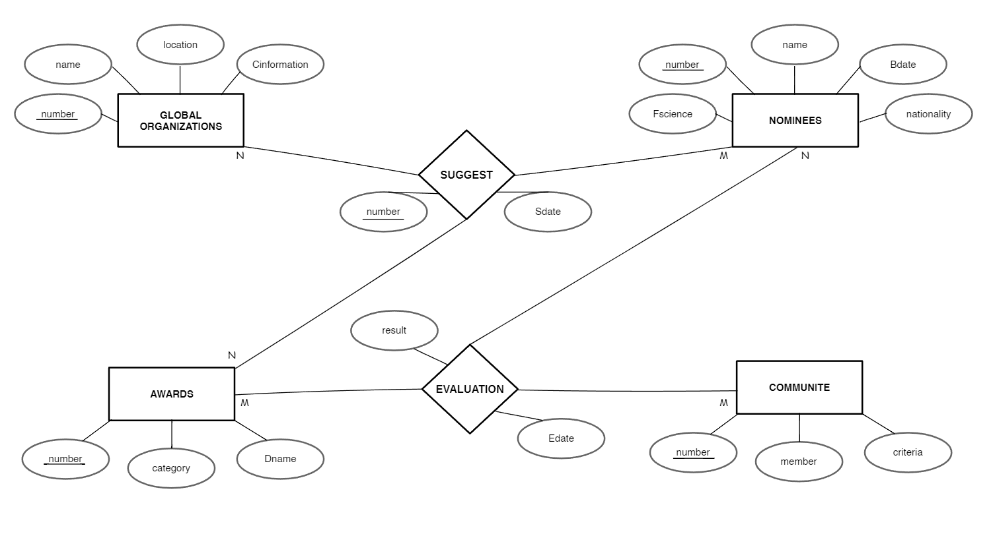Figure 3.1 ER Diagram

2. Create relational tables (7-steps) appropriate to the E-R diagram using ER-to-Relational Mapping algorithms and show the relationships between the tables.

ER model to the relational model mapping is performed using the ER to Relational

**Mapping**

* + Step 1: Mapping of Regular (Strong) Entity Types:

NOMINEES

|  |  |  |  |  |
| --- | --- | --- | --- | --- |
| number | name | Bdate | nationality | Fscience |

AWARDS

|  |  |  |
| --- | --- | --- |
| number | category | Dname |

GLOBAL_ORGANIZATIONS

|  |  |  |  |
| --- | --- | --- | --- |
| number | name | location | Cinformation |

COMMUNITE

|  |  |  |
| --- | --- | --- |
| number | member | criteria |

* + Step 2: Mapping of Weak Entity Types

There is not weak entity.

* + Step 3: Mapping of Binary 1:1 Relation Types

There is not 1:1 relationship

* + Step 4: Mapping of Binary 1: N Relationship Types

There is not 1:N relationship

* + Step 5: Mapping of Binary M: N Relationship Types

There is not M:N relationship

* + Step 6: Mapping of Multi-valued attributes

There is no multi-valued attribute.

* + Step 7: Mapping of N-ary Relationship Types

EVALUATION

|  |  |  |  |  |
| --- | --- | --- | --- | --- |
| A_number | N_number | C_number | result | Edate |

SUGGEST

|  |  |  |  |  |
| --- | --- | --- | --- | --- |
| A_number | N_number | O_number | date | number |

NOMINEES

|  |  |  |  |  |
| --- | --- | --- | --- | --- |
| number | name | Bdate | nationality | Fscience |

AWARDS

|  |  |  |
| --- | --- | --- |
| number | category | Dname |

GLOBAL_ORGANIZATIONS

|  |  |  |  |
| --- | --- | --- | --- |
| number | name | location | Cinformation |

COMMUNITE

|  |  |  |
| --- | --- | --- |
| number | member | criteria |

EVALUATION

|  |  |  |  |  |
| --- | --- | --- | --- | --- |
| A_number | N_number | C_number | result | Edate |

SUGGEST

|  |  |  |  |  |
| --- | --- | --- | --- | --- |
| A_number | N_number | O_number | Sdate | number |

**3. Normalization**

**1-NF**

All tables in the scenario follow the 1-NF format.

**2-NF**

All tables in the scenario follow the 2-NF format.

**3-NF**

All tables in the scenario follow the 3-NF format.

**4. Using SQL Server Management Studio (SSMS), create the database using SQL commands.**

CREATE TABLE NOMINEES (

number INT NOT NULL PRIMARY KEY,

name VARCHAR(100) NOT NULL,

Bdate DATE NOT NULL,

nationality VARCHAR(50) NOT NULL,

Fscience VARCHAR(50) NOT NULL

);

CREATE TABLE AWARDS (

number INT NOT NULL PRIMARY KEY,

category VARCHAR(50) NOT NULL,

Dname VARCHAR(50) NOT NULL

);

CREATE TABLE GLOBAL_ORGANIZATIONS(

number INT NOT NULL PRIMARY KEY,

name VARCHAR(50) NOT NULL,

location VARCHAR(100) NOT NULL,

Cinformation VARCHAR(100) NOT NULL

);

CREATE TABLE COMMUNITE (

number INT NOT NULL PRIMARY KEY,

member VARCHAR(100) NOT NULL,

criteria VARCHAR(50) NOT NULL

);

CREATE TABLE EVALUATION (

Edate DATE NOT NULL,

result VARCHAR(50) NOT NULL,

N_number INT NOT NULL,

C_number INT NOT NULL ,

A_number INT NOT NULL ,

FOREIGN KEY (N_number) REFERENCES NOMINEES(number) ON DELETE CASCADE,

FOREIGN KEY (C_number) REFERENCES COMMUNITE(number) ON DELETE CASCADE,

FOREIGN KEY (A_number) REFERENCES AWARDS(number) ON DELETE CASCADE );

CREATE TABLE SUGGEST (

number INT NOT NULL PRIMARY KEY,

Sdate DATE NOT NULL,

N_number INT NOT NULL,

O_number INT NOT NULL,

A_number INT NOT NULL ,

FOREIGN KEY (O_number) REFERENCES GLOBAL _ORGANIZATIONS(number) ON DELETE CASCADE,

FOREIGN KEY (N_number) REFERENCES NOMINEES(number) ON DELETE CASCADE,

FOREIGN KEY (A_number) REFERENCES AWARDS(number) ON DELETE CASCADE

);

5.

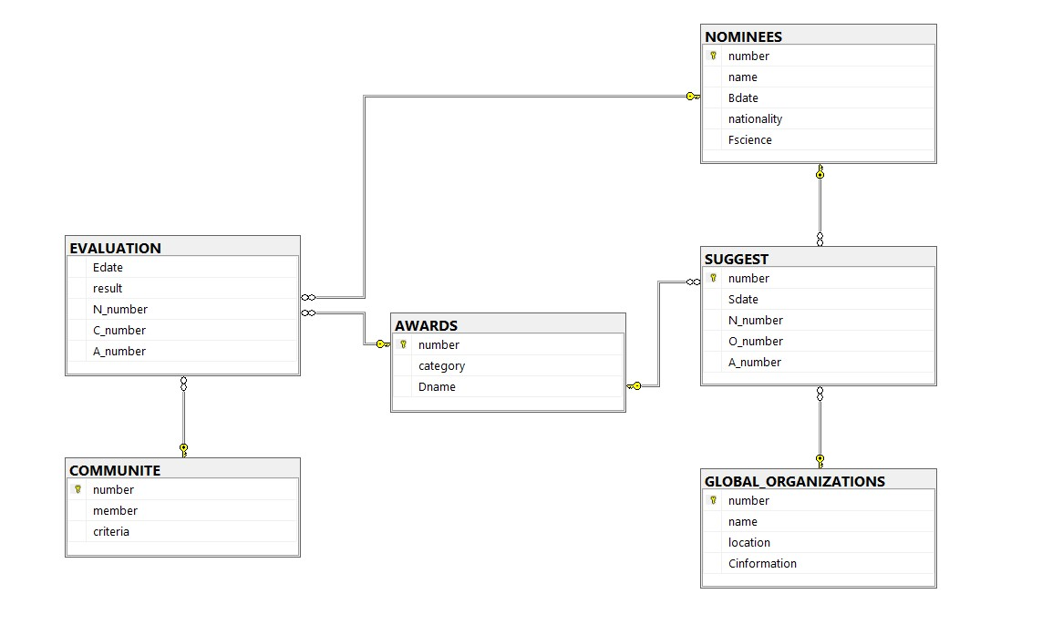

**6. Populate your tables with insert command.**

INSERT INTO NOMINEES(number, name, Bdate, nationality, Fscience)

VALUES (1, 'Marie Curie', '1867-11-07', 'Polish', 'Physics'),

(2, 'Albert Einstein', '1879-03-14', 'German', 'Physics'),

(3, 'Rosalind Franklin', '1920-07-25', 'British', 'Chemistry'),

(4, 'Jonas Salk', '1914-10-28', 'American', 'Medicine'),

(5, 'William Faulkner', '1897-09-25', 'American', 'Literature'),

(6, 'Mark Due', '1870-04-13', 'Egyptian', 'Physics'),

(7, 'Aziz Sancar', '1903-08-26', 'Turkish', 'Chemistry'),

(8, 'Kemal Mr', '1927-07-21', 'Dutch', 'Economy'),

(9, 'Lord Rayleigh', '1901-11-30', 'Brazilian', 'Physics'),

(10, 'Jerry Konp', '1894-10-28', 'Greek', 'Economy');

INSERT INTO AWARDS(number, category, Dname)

VALUES (1, 'Physics', 'Nobel Prize in Physics'),

(2, 'Chemistry', 'Nobel Prize in Chemistry'),

(3, 'Medicine', 'Nobel Prize in Physiology or Medicine'),

(4, 'Literature', 'Nobel Prize in Literature'),

(5, 'Peace', 'Nobel Peace Prize'),

(6, 'Economy', 'Nobel Prize in Economy');

INSERT INTO GLOBAL_ORGANIZATIONS(number, name, location, Cinformation)

VALUES (1, 'The Royal Swedish Academy of Sciences', 'Sweden', 'info@kva.se'),

(2, 'Nobel Assembly at the Karolinska Institute', 'Sweden', 'nobelprize@ki.se'),

(3, 'Norwegian Nobel Committee', 'Norway', ['postmaster@nobel.no](mailto:'postmaster@nobel.no)'),

(4, 'The Purple Russian Academy of Sciences', 'Russia', 'info@kva.se'),

(5, 'Turkey Science Institute', 'Turkey', 'turkeyscience@ıns.se'),

(6, 'Turkey Nobel Committee', 'Turkey', 'info@nobel.no');

INSERT INTO COMMUNITE(number, member, criteria)

VALUES

(1, 'Hatice Serin', 'Criteria A'),

(2, 'Güller Kalyoncu', 'Criteria B'),

(3, 'Malik Uğur', 'Criteria C'),

(4, 'İbrahim Arpacı', 'Criteria D'),

(5, 'Sude Öztaş', 'Criteria E'),

(6, 'Roses Kalyoncu', 'Criteria F'),

(7, 'Peri Uzun', 'Criteria G'),

(8, 'Fatma Kol', 'Criteria H'),

(9, 'Sultan Kur', 'Criteria J'),

(10, 'Deniz Altun', 'Criteria K');

INSERT INTO EVALUATION (A_number, N_number, C_number, result, Edate)

VALUES (1, 1, 1, 'Accepted', '1922-06-30'),

(2, 2, 2, 'Rejected', '1951-08-15'),

(3, 3, 3, 'Accepted', '1955-10-20'),

(4, 4, 4, 'Accepted', '1949-12-31'),

(5, 5, 5, ' Rejected ', '1952-1-1'),

(6, 6, 6, 'Accepted', '1917-07-29'),

(6, 7, 5, 'Rejected', '1946-11-17'),

(5, 8, 3, 'Accepted', '1951-03-23'),

(4, 9, 2, ' Rejected ', '1943-12-14'),

(3, 1, 1, 'Accepted', '1958-01-23');

INSERT INTO SUGGEST (A_number, N_number, O_number, Sdate, number)

VALUES (1, 1, 1, '1923-06-30', 1),

(2, 2, 2, '1952-08-15',2),

(3, 3, 3, '1956-10-20',3),

(4, 4, 2, '1950-12-31',4),

(5, 5, 1, '1953-1-1',5),

(6, 6, 6, '1921-06-14', 6),

(4, 7, 5, '1960-08-26',7),

(5, 8, 4, '1956-09-25',8),

(2, 9, 1, '1957-07-14',9),

(1, 10, 6, '1945-01-15',10);

**7. Test select, insert, delete and update commands.**

// Delete Section

DELETE FROM NOMINEES

WHERE number = 3;

DELETE FROM AWARDS

WHERE number = 5;

DELETE FROM GLOBAL_ORGANIZATIONS

WHERE number = 1;

DELETE FROM COMMUNITE

WHERE number = 1;

DELETE FROM EVALUATION

WHERE A_number = 3;

DELETE FROM SUGGEST

WHERE number = 7;

// Select Section

SELECT *

FROM NOMINEES

SELECT *

FROM AWARDS

SELECT *

FROM GLOBAL_ORGANIZATIONS

SELECT *

FROM COMMUNITE

SELECT *

FROM EVALUATION

SELECT *

FROM SUGGEST

// Update Section

UPDATE NOMINEES

SET name = 'Guller Kalyoncu'

WHERE name = 'Jonas Salk';

UPDATE AWARDS

SET category = ‘Muslim’

WHERE Dname = ‘Nobel Prize in Physics’;

UPDATE GLOBAL_ORGANIZATIONS

SET location = ‘Balikli’

WHERE name = 'Jonas Salk';

UPDATE COMMUNITE

SET criteria = ‘Criteria C’

WHERE member= 'Hatice Serin';

UPDATE EVALUATION

SET A_number = 1

WHERE Edate = '1922-06-30';

UPDATE SUGGEST

SET O_number = 1

WHERE Sdate= '1923-06-30';